

**WORKERS’ COMPENSATION DISCOUNT**

**WITH**

**CHAMBER OF COMMERCE OF HARRISON COUNTY BENEFITS**

The Chamber of Commerce of Harrison County has partnered with ClearPath Mutual, creating a Workers’ Compensation Program offering their members:

* GREAT RATES
* EXCELLENT SERVICE
* 10% ASSOCIATION DISCOUNT

**Member Qualifications:**

* Must be a member in good standing
* Minimum of 3 years in business
* Experience modification factor of 1.30 or less
* Cooperation with Loss Prevention Services
* All other existing Underwriting Guidelines prevail

**For more information, contact:**

**DISCOUNT**

10%

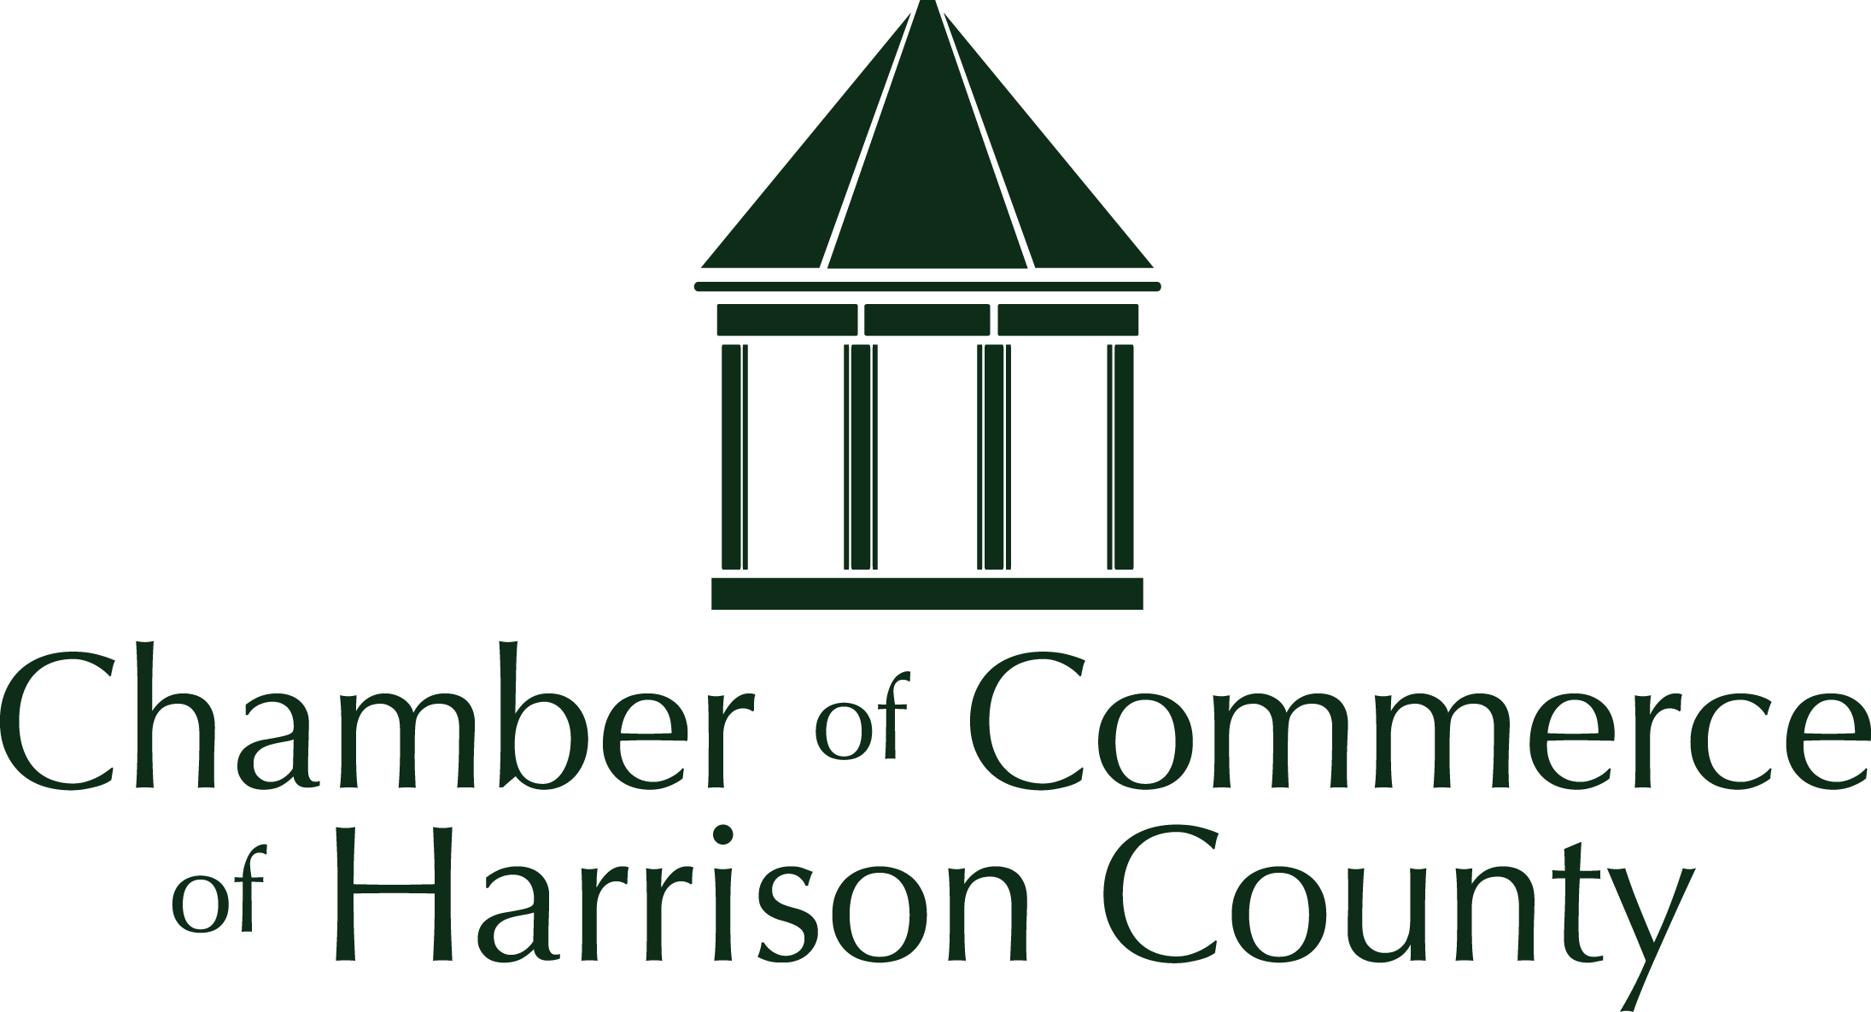





### Rick Kochert

### Account Executive

### Kochert Insurance

### 812-206-7452

### [Rick.Kochert@KochertInsurance.com](mailto:Rick.Kochert@KochertInsurance.com)

### Pam Bennett Martin

### Account Executive

### Bennett & Bennett Insurance

### 812-738-2233

[Pam@bennettins.com](mailto:Pam@bennettins.com)

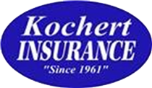





**Please give Rick Kochert or Pam Bennett Martin a call if you are a current member or would like to join,** **so that you can take advantage of this savings for your business!**